Joseph Ayo

Module 7.2 Assignment – CSD 325

1. City_functions.py

2.test_cities.py

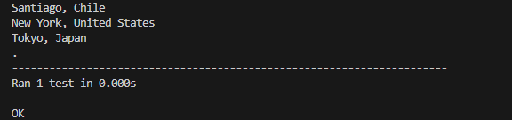

3.test_cities after {population} added to city_functions.py (mandatory):

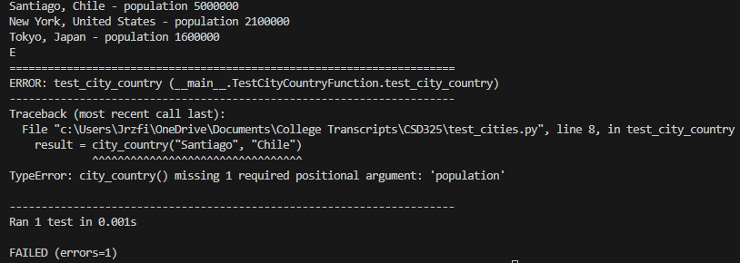

4.test_cities after converting {population} to an optional entry:

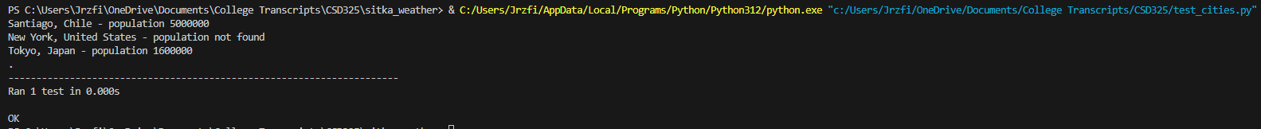

5. test_cities return after adding in language, before modifying test_cities

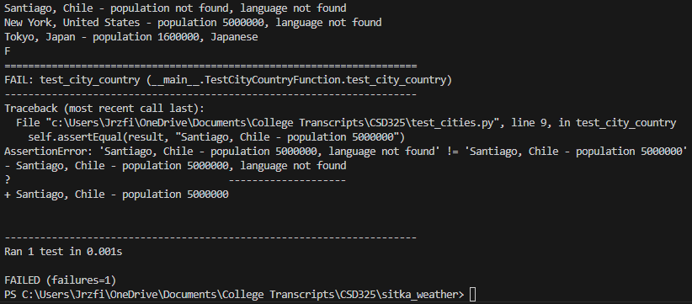

6. test_cities return after modifying for language:

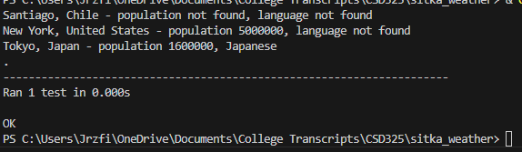

7.city_functions after adding in language:

